EXP. 1: Create a simple cloud software application for Flight Reservation System using any Cloud Service Provider to demonstrate SaaS
Aim:
To create a simple Flight Reservation System using Zoho Creator and demonstrate the Software as a Service (SaaS) model.
Software / Tools Required:
- Zoho Creator
- Web Browser
- Internet Connection
- Laptop/Desktop
Theory:
Software as a Service (SaaS) is a cloud computing model where applications are available over the internet without installing them on a computer.
In this project, a Flight Reservation System is created using Zoho Creator. It allows users to enter passenger details, select flight information, and submit reservations. The data is stored securely in the cloud and can be accessed anytime.
Algorithm:
- Start.
- Open Zoho Creator.
- Enter passenger details.
- Select flight details.
- Choose departure and return dates.
- Enter the number of travellers.
- Select payment and booking status.
- Submit the form.
- Store the data in the cloud.
- Stop.
Form Fields:
Field Name | Field Type
Passenger Name | Name
Address | Address
Email | Email
Phone | Phone
Class | Drop-down
Fare Type | Drop-down
From | Drop-down
To | Drop-down
Trip Type | Radio Button
Flight Type | Radio Button
Departure Date | Date
Return Date | Date
Travellers | Number
Payment Status | Drop-down
Booking Status | Drop-down

Procedure:
- Log in to Zoho Creator.
- Create a new application.
- Create a form named Flight Booking System.
- Add all the required fields.
- Save the form.
- Enter the booking details.
- Click Submit.
- Verify that the data is stored successfully.
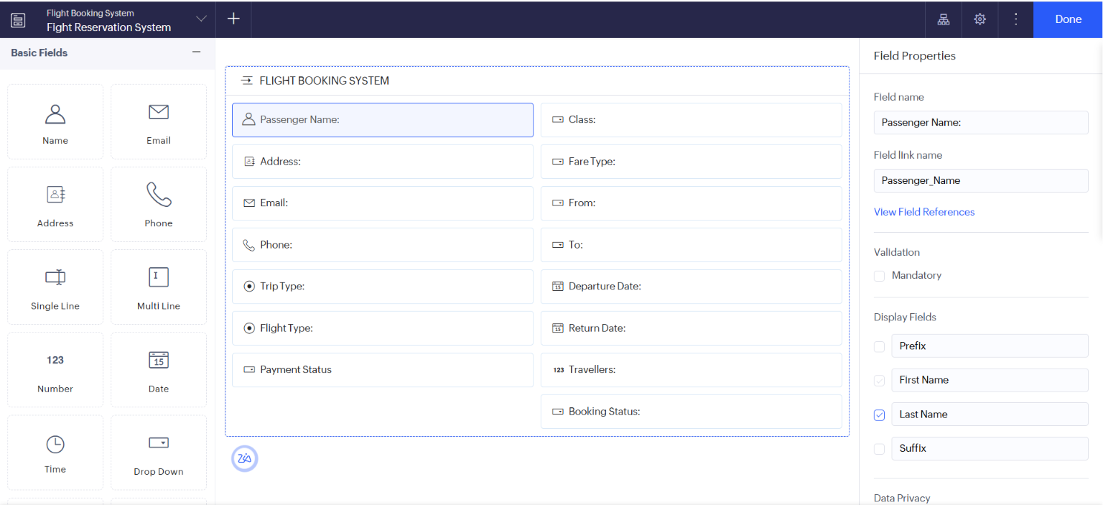
Output:
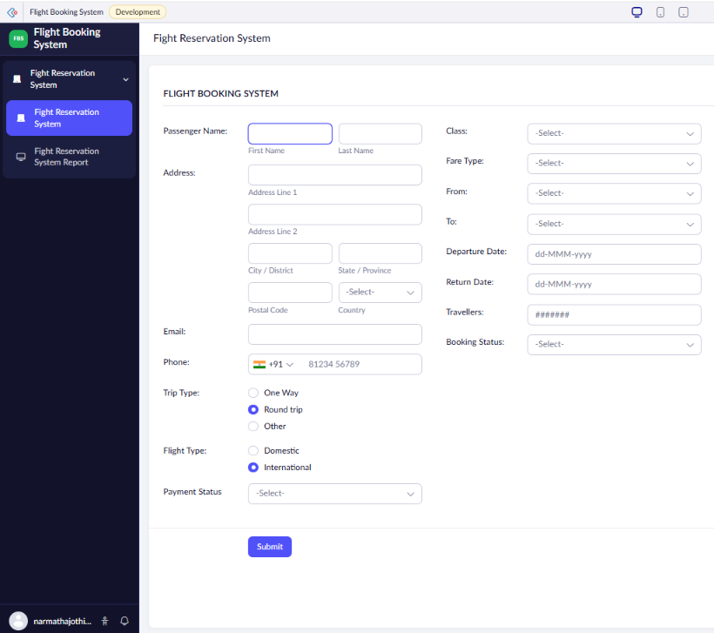

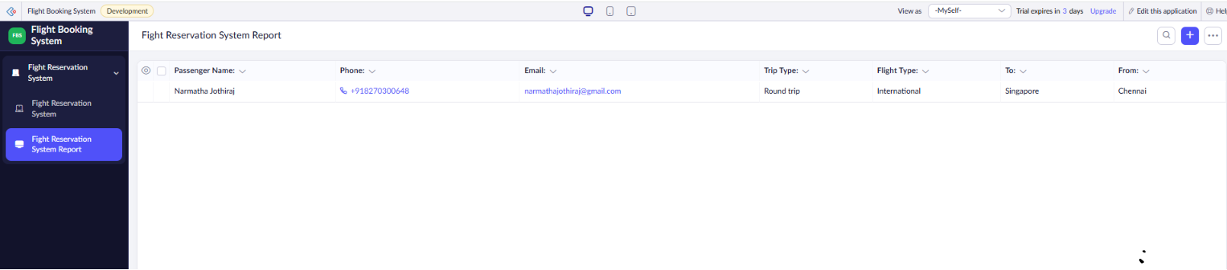

Result:
The Flight Reservation System was successfully created using Zoho Creator. The application stores passenger and flight booking details in the cloud, demonstrating the SaaS model.

EXP. 2: Create a simple cloud software application for Property Buying & Rental process (In Chennai city) using any Cloud Service Provider to demonstrate SaaS
Aim:
To develop a simple Property Buying & Rental Management System using Zoho Creator and demonstrate the Software as a Service (SaaS) model.
Software / Tools Required:
- Zoho Creator
- Web Browser
- Internet Connection
- Laptop/Desktop
Theory:
Software as a Service (SaaS) is a cloud computing model where applications are hosted on the cloud and accessed through the internet.
In this project, a Property Buying & Rental Management System is developed using Zoho Creator. The application allows users to add property details, manage buying and rental information, upload agreements, and maintain property records. The data is stored securely in the cloud and can be accessed anytime through the internet.

Algorithm:
- Start.
- Open the Property Buying & Rental Management application.
- Enter property details.
- Select whether the property is for Buy or Rent.
- Enter owner and contact details.
- Enter property information and upload images.
- Save the property details.
- Create rental agreements if required.
- Store all information in the cloud database.
- View property reports.
- Stop.
Form Fields:
Property Details Form:
Field Name | Field Type
Property ID | Auto Number
Property Type | Drop-down
Buy/Rent | Drop-down
Owner Name | Single Line
Contact Number | Phone
Email | Email
Area (sq.ft) | Number
Place | Drop-down
Address | Multi Line
Property Value | Currency
Rental Amount | Currency
Rental Agreement | File Upload
Bedrooms | Number
Bathrooms | Number
Furnished | Radio Button
Parking | Radio Button
Property Status | Drop-down
Description | Multi Line
Upload Image | Image Upload

Rental Agreement Form:
Field Name | Field Type
Tenant Name | Single Line
Owner Name | Single Line
Property Details | Lookup
Rent Amount | Currency
Advance Amount | Currency
Agreement Date | Date
Agreement End Date | Date
Upload Agreement | File Upload
Remarks | Multi Line

Procedure:
- Log in to Zoho Creator.
- Create a new application named Property Buying & Rental Management.
- Create the Property Details form.
- Add all the required fields.
- Create the Rental Agreement form.
- Configure reports for viewing property records.
- Save the application.
- Enter sample property and rental details.
- Submit the form.
- Verify that the records are stored successfully in the cloud.

Output:
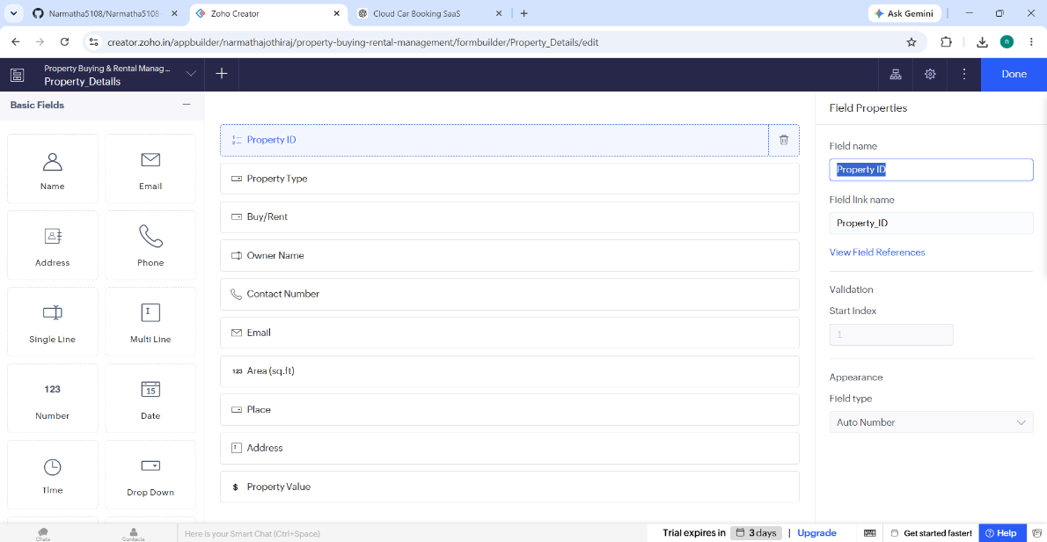

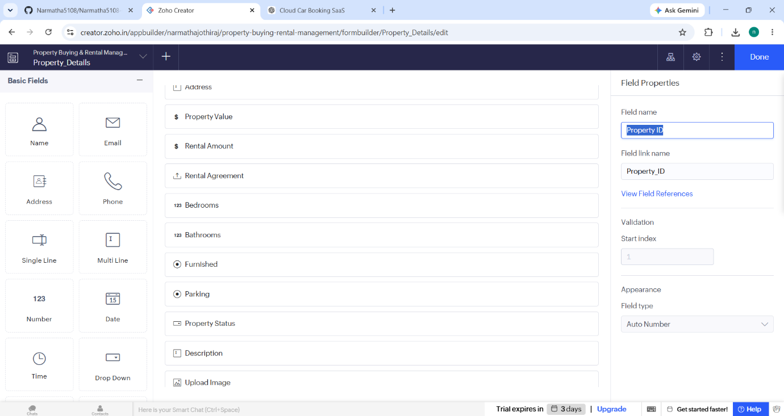

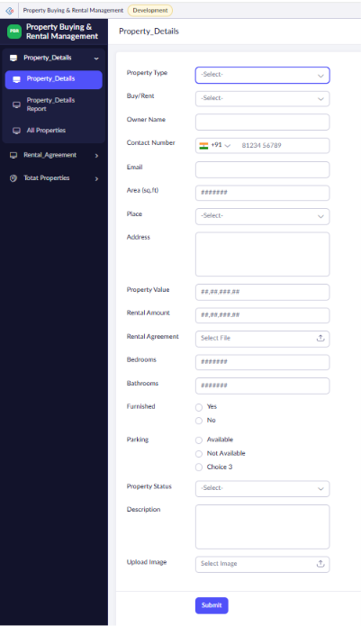

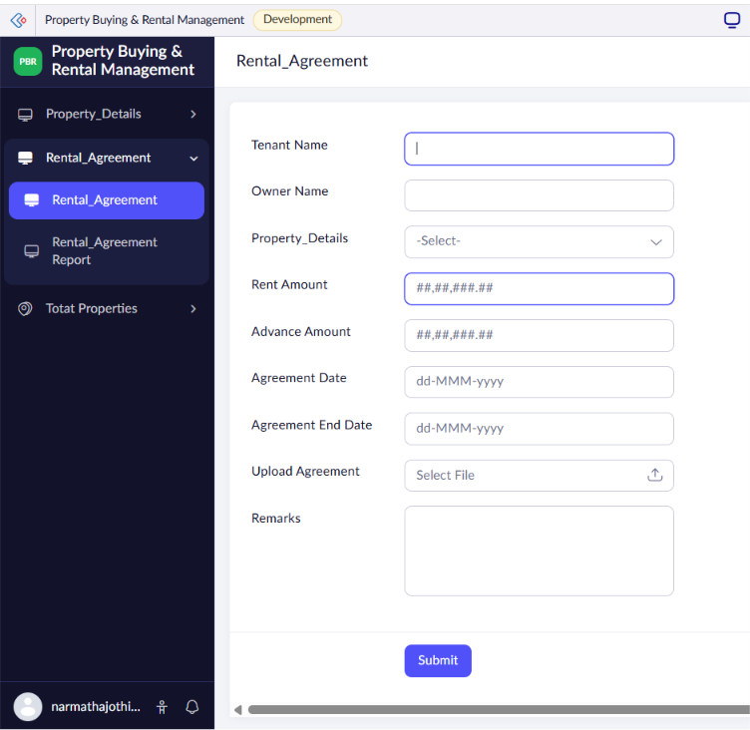

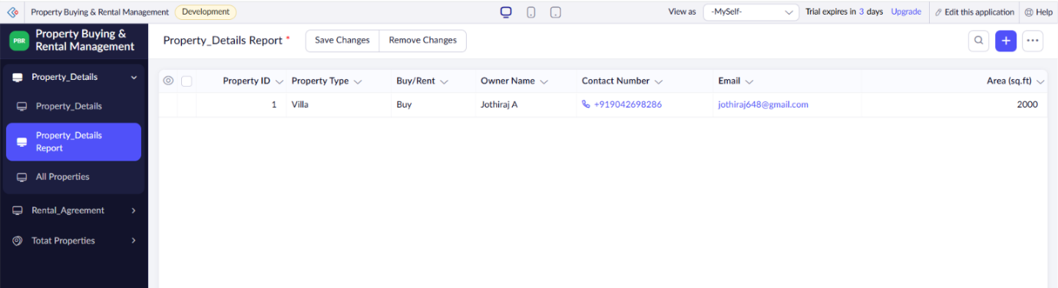
Result:
The Property Buying & Rental Management System was successfully developed using Zoho Creator. The application enables users to manage property buying and rental information, maintain rental agreements, upload property images, and store all records securely in the cloud. This demonstrates the implementation of the Software as a Service (SaaS) model using Zoho Creator.

EXP. 3: Create a simple cloud software application for Car Booking Reservation System using any Cloud Service Provider to demonstrate SaaS include the necessary fields such as search for cabs, from, to, rental, out station, Package type, hours/Days etc.
Aim:
To develop a simple Car Booking Reservation System using Zoho Creator and demonstrate the Software as a Service (SaaS) model.
Software / Tools Required:
- Zoho Creator
- Web Browser
- Internet Connection
- Laptop/Desktop
Theory:
Software as a Service (SaaS) is a cloud computing model where software applications are hosted on the cloud and accessed through the internet.
In this project, a Car Booking Reservation System is developed using Zoho Creator. The application allows users to search for cabs, choose pickup and destination locations, select rental or outstation trips, choose package type, enter travel details, and book a car online. All booking details are stored securely in the cloud and can be accessed anytime.
Algorithm:
- Start.
- Open the Car Booking Reservation System.
- Enter customer details.
- Search and select the cab type.
- Choose the pickup (From) and destination (To) locations.
- Select Trip Type (Rental/Outstation).
- Choose the package type.
- Enter rental hours or outstation days.
- Select pickup date and time.
- Choose the payment mode.
- Submit the booking form.
- Store the booking details in the cloud database.
- Display the booking status.
- Stop.
Form Fields:
Field Name | Field Type
Booking ID | Auto Number
Customer Name | Name
Mobile Number | Phone
Email | Email
Search for Cabs | Drop-down
From | Drop-down
To | Drop-down
Trip Type (Rental/Outstation) | Radio Button
Package Type | Drop-down
Rental Duration (Hours) | Drop-down
Outstation Days | Number
Pickup Date | Date
Pickup Time | Time
Number of Passengers | Number
Car Type | Drop-down
Payment Mode | Drop-down
Booking Status | Drop-down

Procedure:
- Log in to Zoho Creator.
- Create a new application named Car Booking Reservation System.
- Create a form named Car Booking.
- Add all the required fields.
- Configure drop-down lists and radio buttons.
- Save the form.
- Enter sample booking details.
- Click Submit.
- Verify that the booking details are stored successfully in the cloud database.
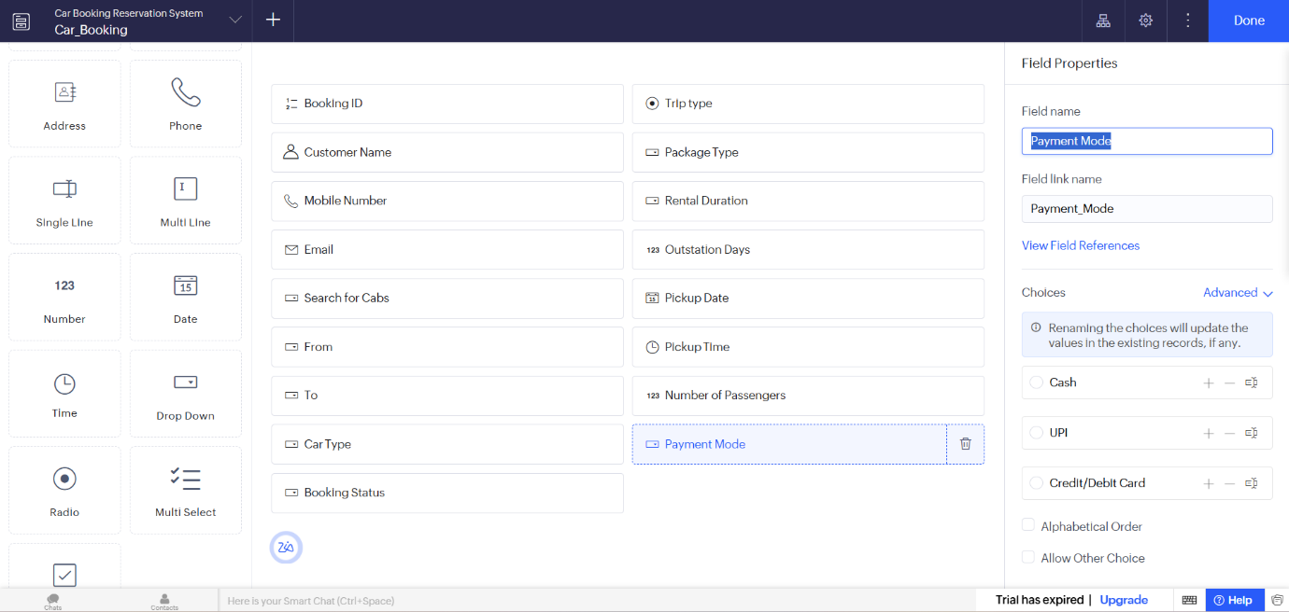
Output:
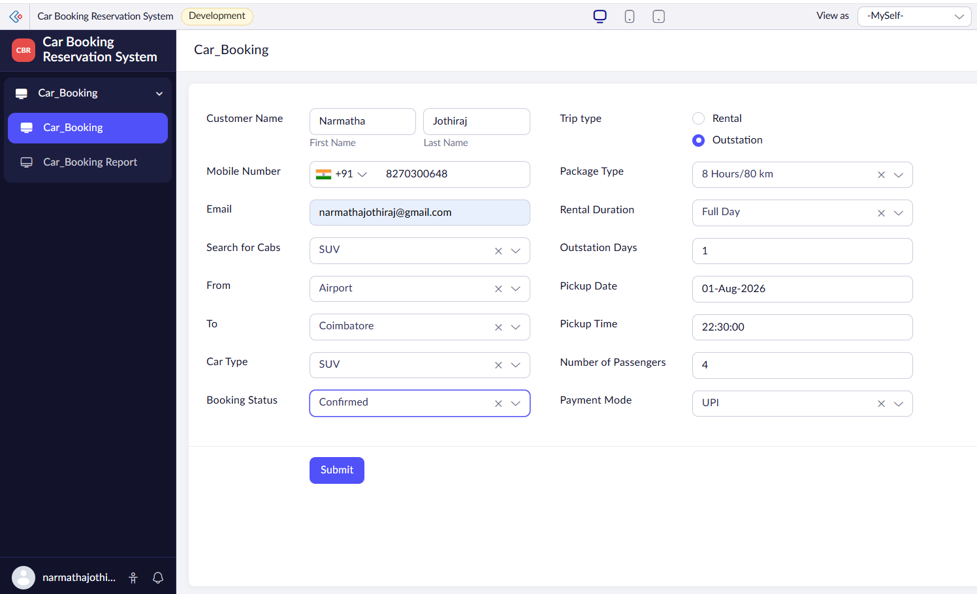

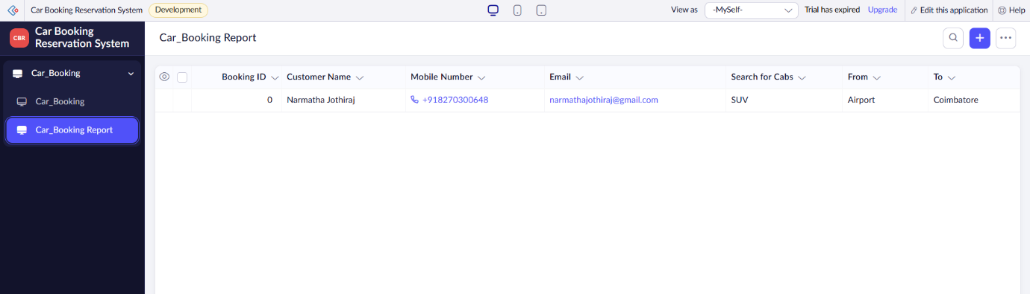

Result:
The Car Booking Reservation System was successfully developed using Zoho Creator. The application enables users to search for cabs, select rental or outstation trips, enter booking details, and store the information securely in the cloud. This demonstrates the implementation of the Software as a Service (SaaS) model.

EXP. 4: Create a simple cloud software application for Library book reservation system for SIMATS library using any Cloud Service Provider to demonstrate SaaS include the necessary fields such as Title of the book, author, publications, Year, edition, no of copies, Rack no, status (taken/returned) etc.

Aim:
To develop a simple Library Book Reservation System for SIMATS Library using Zoho Creator and demonstrate the Software as a Service (SaaS) model.
Software / Tools Required:
- Zoho Creator
- Web Browser
- Internet Connection
- Laptop/Desktop
Theory:
Software as a Service (SaaS) is a cloud computing model where software applications are hosted on the cloud and accessed through the internet.
In this project, a Library Book Reservation System is developed using Zoho Creator. The application allows users to store and manage book details such as title, author, publication, year, edition, number of copies, rack number, and book status. The library records are stored in the cloud and can be accessed and managed easily.
Algorithm:
- Start.
- Open the Library Book Reservation System.
- Enter the book details.
- Enter the title and author name.
- Enter publication, year, and edition.
- Enter the number of copies.
- Enter the rack number.
- Select the book status.
- Submit the form.
- Store the book details in the cloud database.
- View and manage the library records.
- Stop.
Form Fields:
Field Name | Field Type
Book ID | Auto Number
Title of the Book | Single Line
Author | Single Line
Publication | Single Line
Year | Number
Edition | Drop-down
No. of Copies | Number
Rack No. | Number
Book Status | Drop-down
Student Name | Name
Student ID | Single Line
Reservation Date | Date
Return Date | Date

Procedure:
- Log in to Zoho Creator.
- Create a new application named SIMATS Library Book Reservation System.
- Create a form named Book Reservation.
- Add all the required book and student fields.
- Add dropdown options for Edition and Book Status.
- Save the form.
- Enter sample book and student details.
- Click Submit.
- Verify that the details are stored successfully in the cloud database.
- View the book records using the generated report.

Output:
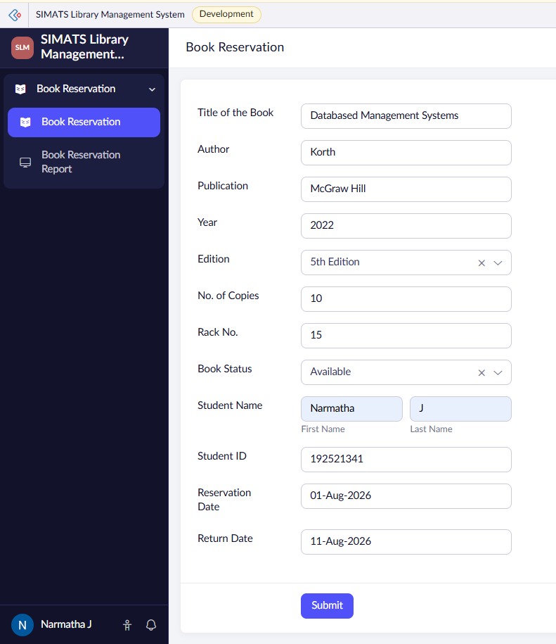
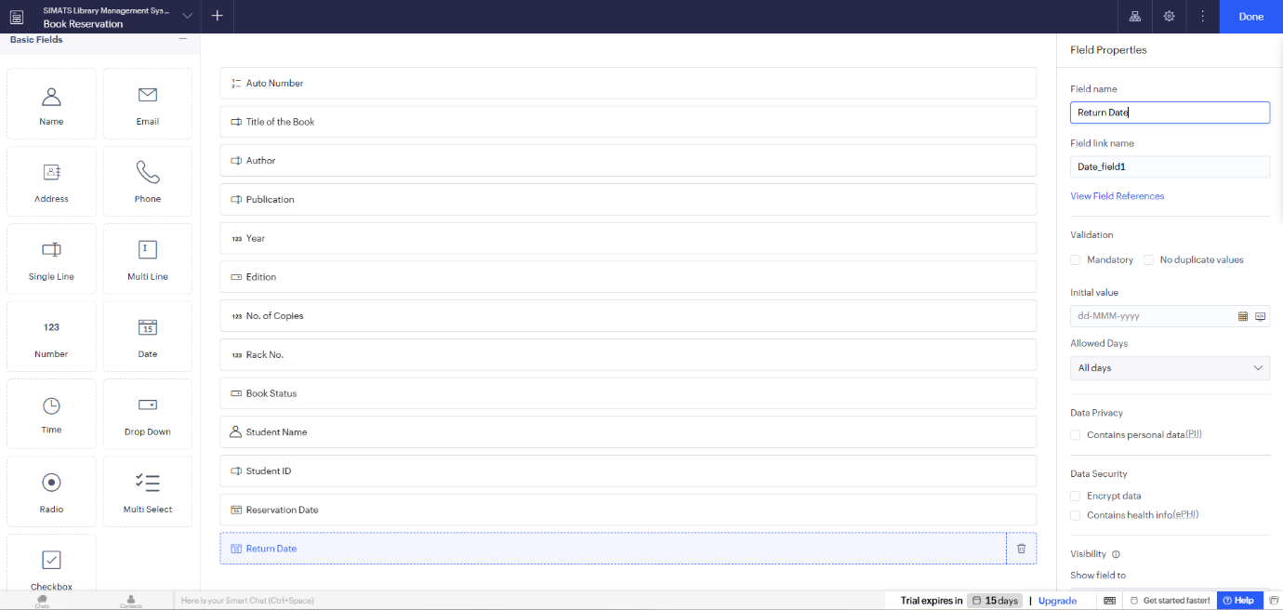

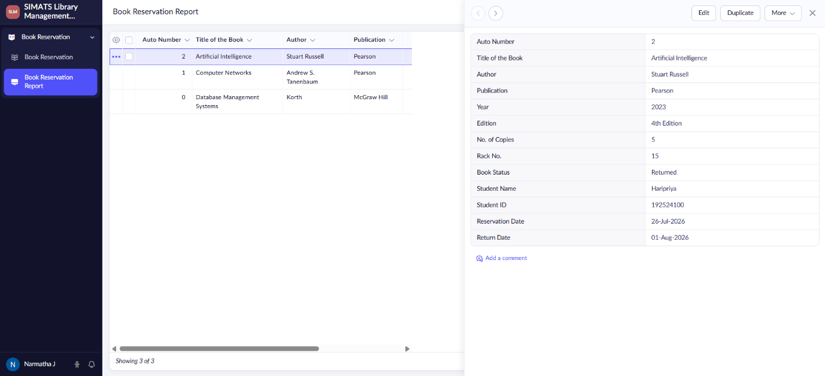

Result:
The SIMATS Library Book Reservation System was successfully developed using Zoho Creator. The application allows users to manage book details, check book availability, reserve books, and maintain taken and returned status. The information is stored in the cloud, demonstrating the Software as a Service (SaaS) model.

EXP. 5: Create a simple cloud software application for Mark Sheet Processing System using any Cloud Service Provider to demonstrate SaaS include the necessary fields such as name of the student, Reg no of the student , Subjects , Marks, Average, percentage, rank, overall performance etc.

Aim:
To develop a simple Mark Sheet Processing System using Zoho Creator and demonstrate the Software as a Service (SaaS) model.
Software / Tools Required:
- Zoho Creator
- Web Browser
- Internet Connection
- Laptop/Desktop
Theory:
Software as a Service (SaaS) is a cloud computing model in which applications are hosted on the cloud and accessed through the internet without installing them on a local computer.
In this project, a Mark Sheet Processing System is developed using Zoho Creator. The application allows users to enter student details, subject names, marks, total marks, average, percentage, rank, and overall performance. All the information is stored securely in the cloud and can be accessed and managed anytime.
Algorithm:
- Start.
- Open the Mark Sheet Processing System.
- Enter the student details.
- Enter the subject names and marks.
- Calculate the total marks.
- Calculate the average and percentage.
- Assign the student's rank.
- Select the overall performance.
- Submit the form.
- Store the data in the cloud database.
- Display the student's mark sheet.
- Stop.
Form Fields:
Field Name | Field Type
Student Name | Name
Register Number | Single Line
Department | Drop-down
Semester | Drop-down
Subject 1 | Single Line
Marks 1 | Number
Subject 2 | Single Line
Marks 2 | Number
Subject 3 | Single Line
Marks 3 | Number
Subject 4 | Single Line
Marks 4 | Number
Subject 5 | Single Line
Marks 5 | Number
Total Marks | Number
Average | Decimal
Percentage | Decimal
Rank | Number
Overall Performance | Drop-down

Procedure:
- Log in to Zoho Creator.
- Create a new application named Mark Sheet Processing System.
- Create a form named Mark Sheet.
- Add all the required fields.
- Configure drop-down lists for Department, Semester, and Overall Performance.
- Save the form.
- Enter the student's details and marks.
- Calculate and enter the total, average, percentage, and rank.
- Click Submit.
- Verify that the mark sheet details are stored successfully in the cloud database.
- View the records using the generated report.
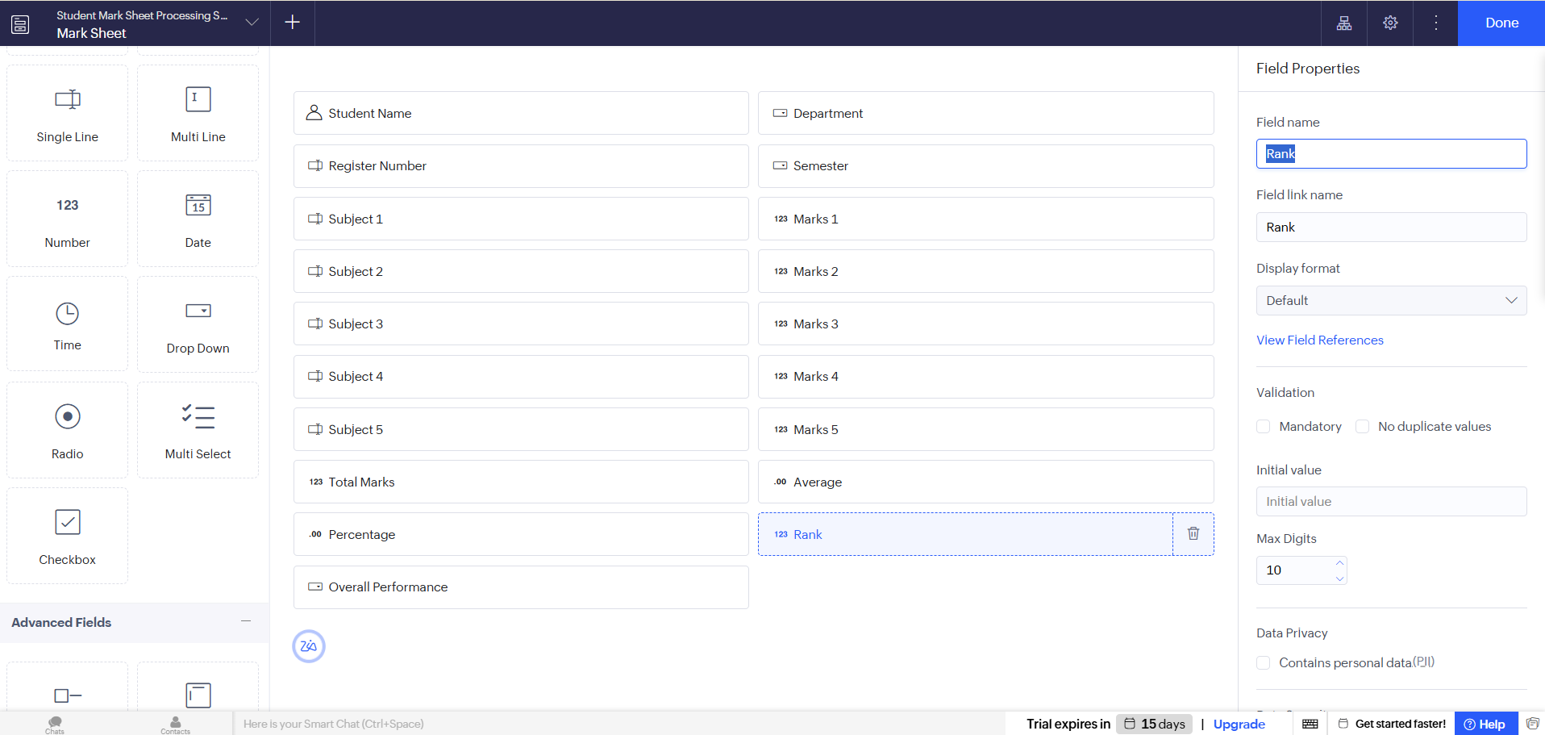
Output:
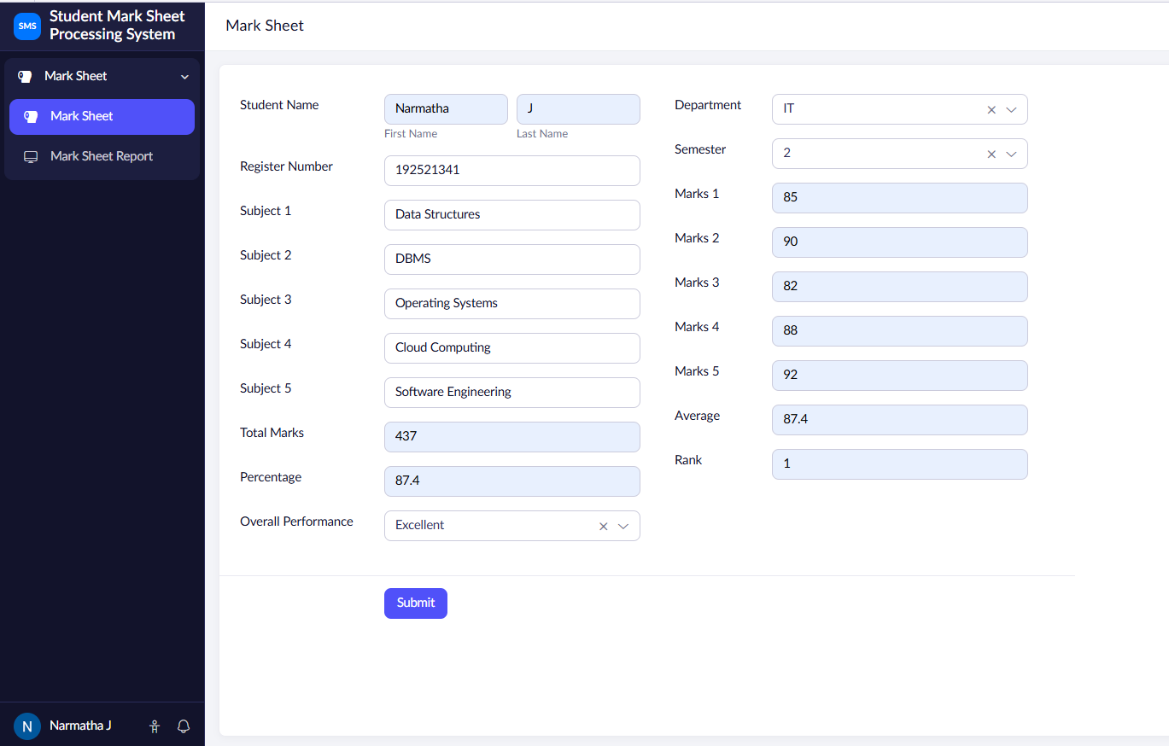
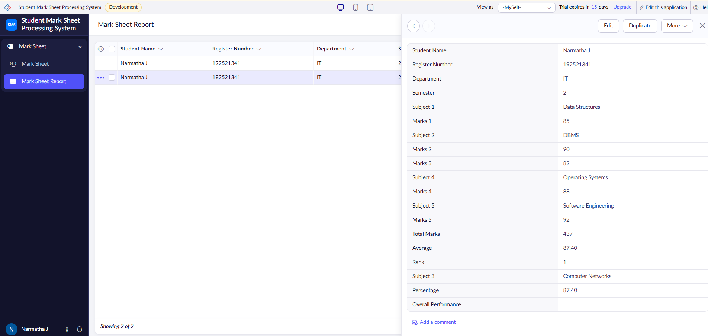
Result:
The Mark Sheet Processing System was successfully developed using Zoho Creator. The application allows users to enter student information, process marks, calculate results, and store the data securely in the cloud. This demonstrates the implementation of the Software as a Service (SaaS) model using Zoho Creator.

EXP. 6: Create a simple cloud software application for Payroll Processing System using any Cloud Service Provider to demonstrate SaaS include the necessary fields such as Name of the employee, experience in present org , over all experience, basic pay, HRA, DA, TA, net pay, gross pay etc.
Aim:
To develop a simple Payroll Processing System using Zoho Creator and demonstrate the Software as a Service (SaaS) model.
Software / Tools Required:
- Zoho Creator
- Web Browser
- Internet Connection
- Laptop/Desktop
Theory:
Software as a Service (SaaS) is a cloud computing model where applications are hosted on the cloud and accessed through the internet.
In this project, a Payroll Processing System is developed using Zoho Creator. The application allows users to maintain employee details, salary information, allowances, gross pay, and net pay. The payroll records are stored securely in the cloud and can be accessed anytime through the internet.

Algorithm:
- Start.
- Open the Payroll Processing System.
- Enter employee details.
- Enter experience details.
- Enter salary details such as Basic Pay, HRA, DA, and TA.
- Calculate Gross Pay and Net Pay.
- Select the payment month and payment status.
- Submit the payroll details.
- Store the data in the cloud database.
- View payroll records.
- Stop.
Form Fields:
Field Name | Field Type
Employee ID | Auto Number
Employee Name | Name
Department | Drop-down
Designation | Drop-down
Experience in Present Organization | Number
Overall Experience | Number
Basic Pay | Currency
HRA | Currency
DA | Currency
TA | Currency
Gross Pay | Currency
Net Pay | Currency
Payment Month | Drop-down
Payment Status | Drop-down

Procedure:
- Log in to Zoho Creator.
- Create a new application named Payroll Processing System.
- Create a form named Employee Payroll.
- Add all the required fields.
- Configure the drop-down lists.
- Save the form.
- Enter employee and salary details.
- Calculate and enter Gross Pay and Net Pay.
- Click Submit.
- Verify that the payroll details are stored successfully in the cloud database.
- View the records using the generated report.
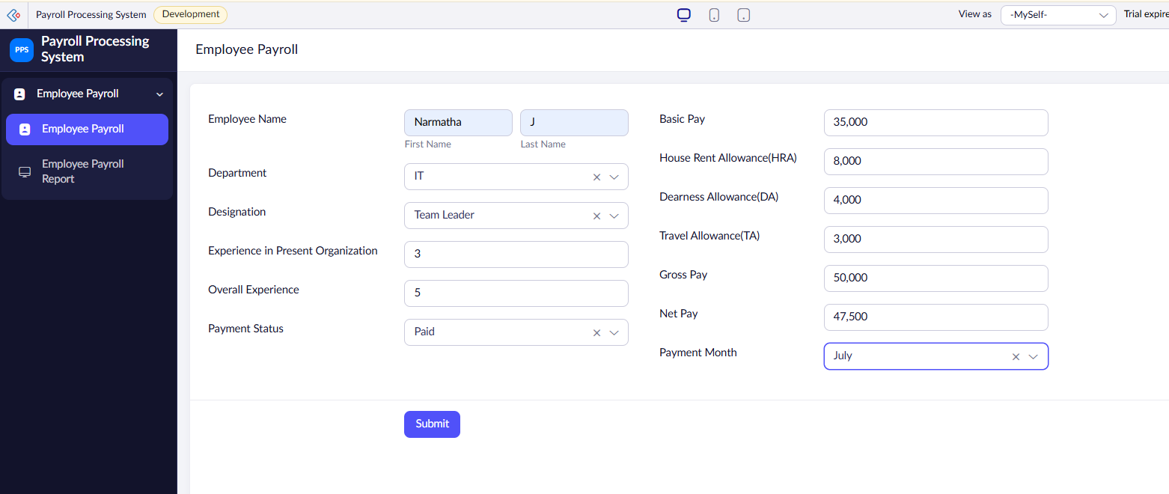
Output:

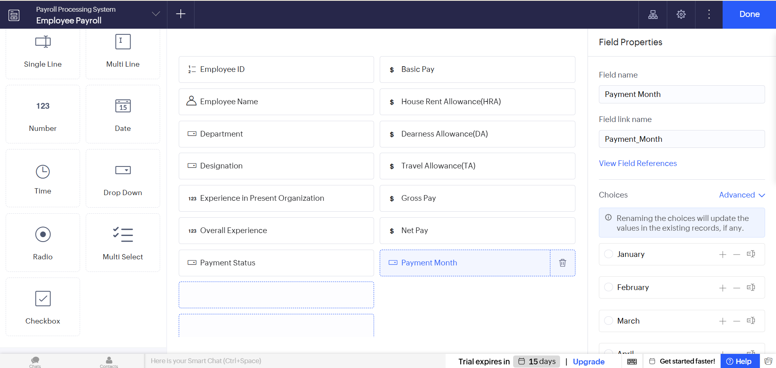

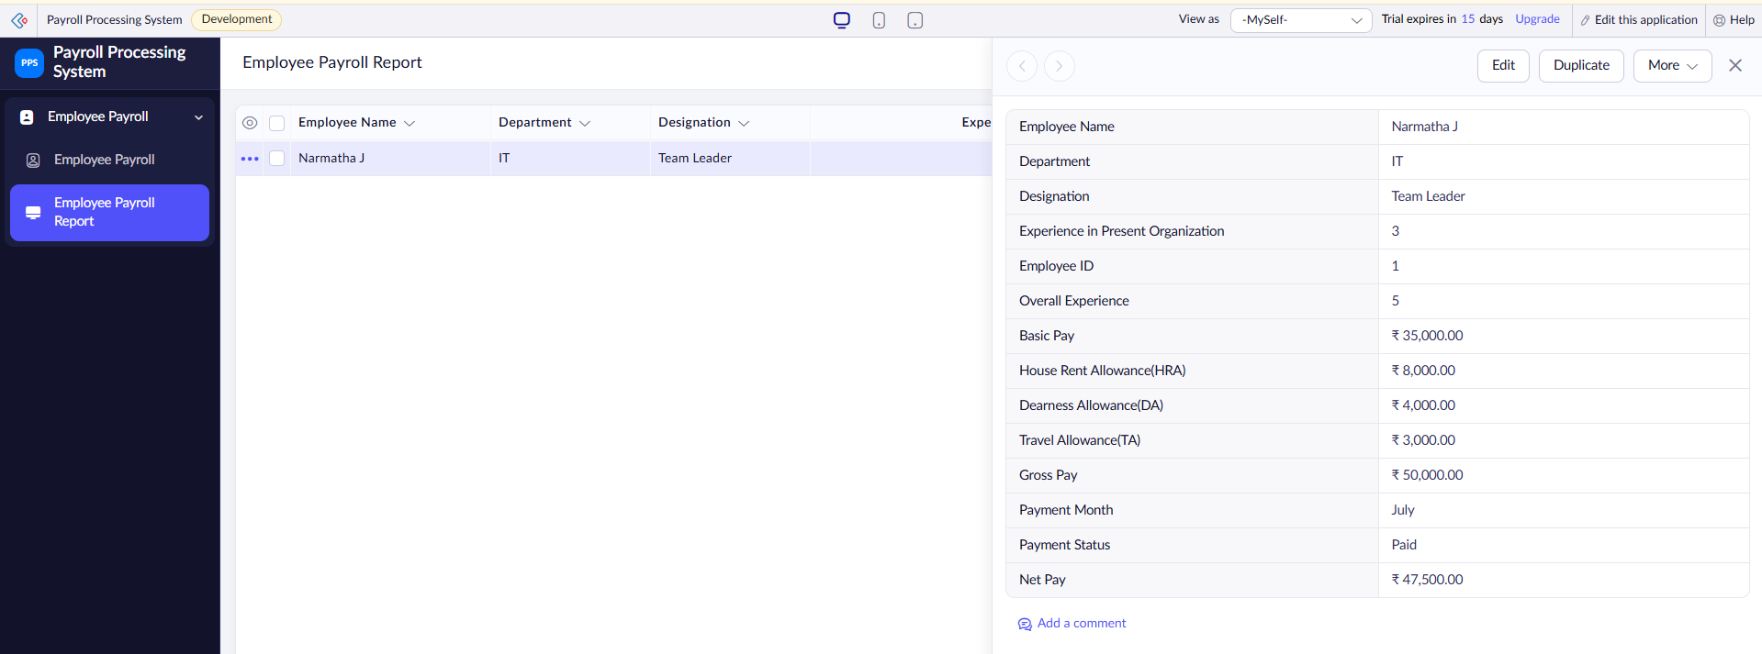

Result:
The Payroll Processing System was successfully developed using Zoho Creator. The application allows users to manage employee salary details, calculate payroll, and store payroll information securely in the cloud. This demonstrates the implementation of the Software as a Service (SaaS) model using Zoho Creator.

EXP. 7: Create a simple cloud software application for Students Attendance System using any Cloud Service Provider to demonstrate SaaS include the necessary fields such as name of the students, course, present , Absent, course attendance, OD request, grade, attendance percentage, etc.

Aim:
To develop a simple Students Attendance System using Zoho Creator and demonstrate the Software as a Service (SaaS) model.
Software / Tools Required:
- Zoho Creator
- Web Browser
- Internet Connection
- Laptop/Desktop
Theory:
Software as a Service (SaaS) is a cloud computing model where applications are hosted on the cloud and accessed through the internet.
In this project, a Students Attendance System is developed using Zoho Creator. The application allows users to record student attendance, manage OD requests, calculate attendance percentage, and maintain grades. The attendance details are stored in the cloud and can be accessed and managed easily.

Algorithm:
- Start.
- Open the Students Attendance System.
- Enter student details.
- Select the course and subject.
- Enter the attendance date.
- Select Present or Absent.
- Enter course attendance.
- Select the OD request status.
- Calculate attendance percentage.
- Assign the grade.
- Submit the form.
- Store the attendance details in the cloud.
- Stop.
Form Fields:
Field Name | Field Type
Student ID | Auto Number
Student Name | Name
Register Number | Single Line
Course | Drop-down
Semester | Drop-down
Subject | Single Line
Attendance Date | Date
Attendance Status | Radio Button
Course Attendance | Number
OD Request | Radio Button
OD Reason | Multi Line
Attendance Percentage | Decimal
Grade | Drop-down

Procedure:
- Log in to Zoho Creator.
- Create a new application named Students Attendance System.
- Create a form named Student Attendance.
- Add all the required fields.
- Configure the dropdowns and radio buttons.
- Save the form.
- Enter sample student attendance details.
- Select Present/Absent and OD status.
- Enter the attendance percentage and grade.
- Click Submit.
- Verify that the attendance details are stored successfully in the cloud database.

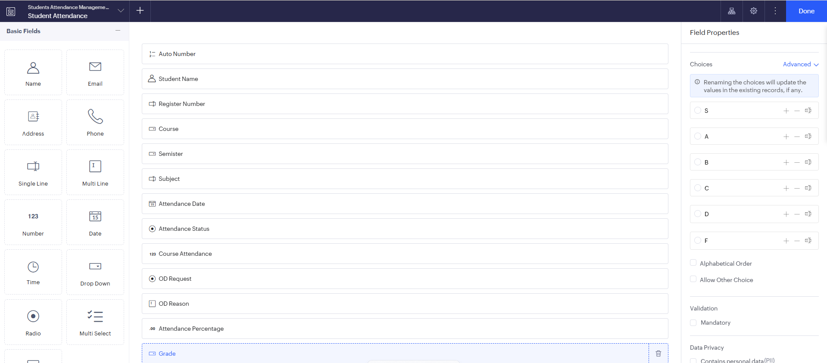
Output:

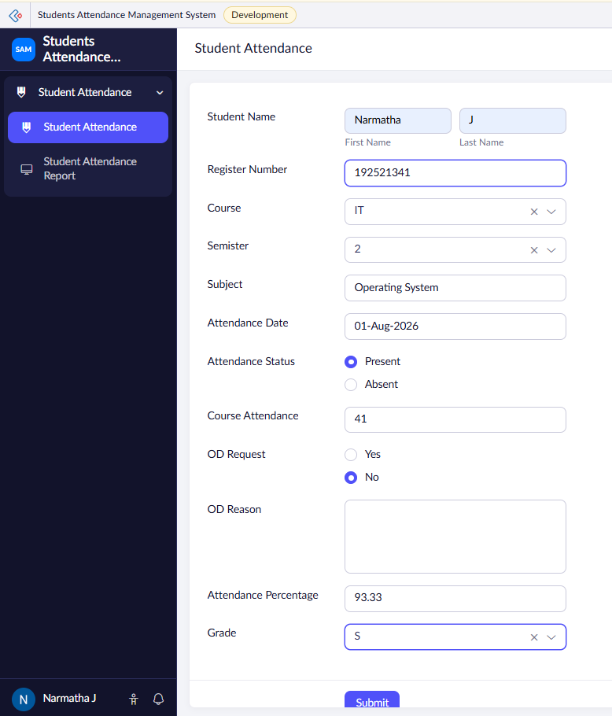

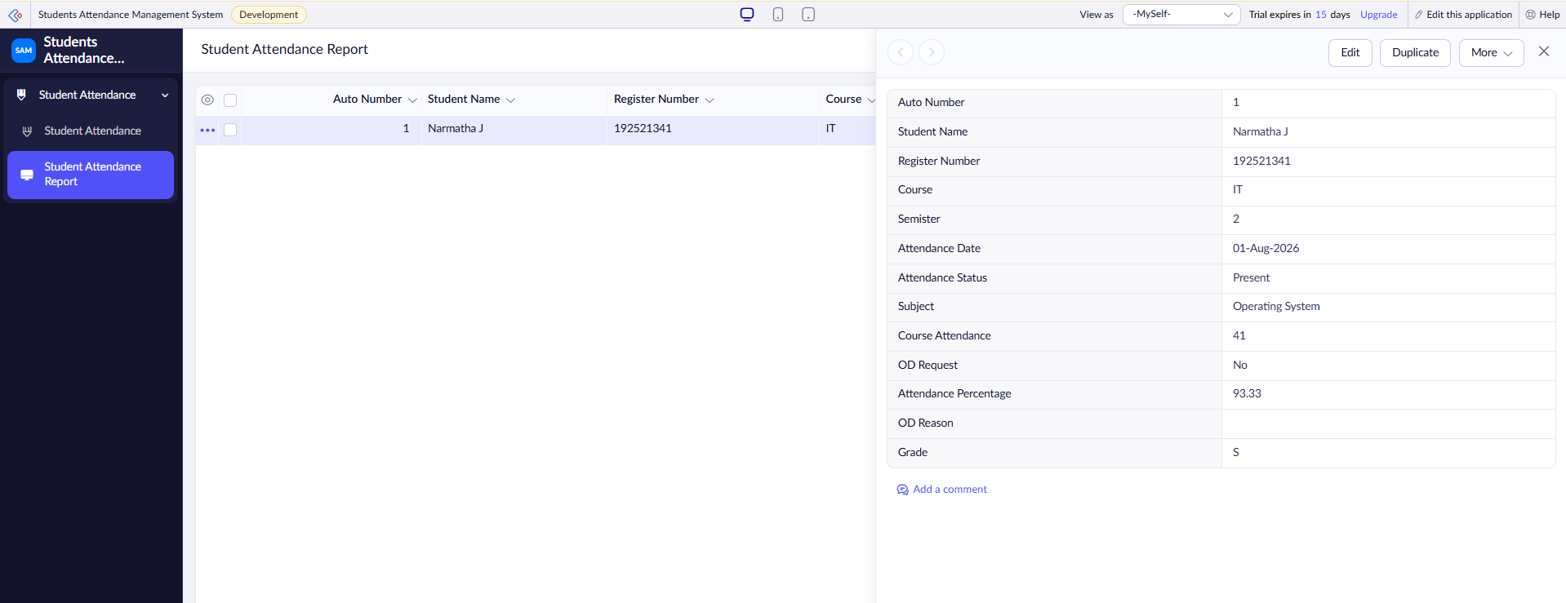
Result:
The Students Attendance System was successfully developed using Zoho Creator. The application allows users to manage student attendance, OD requests, attendance percentage, and grades. The data is stored securely in the cloud, demonstrating the SaaS model.

EXP. 8: Create a simple cloud web application for student counselling system using any Cloud Service Provider to demonstrate SaaS with the fields of student name, age, address, phone, subjects studied, Year of passing, percentage of marks, domain interest, etc.

Aim:
To develop a simple Student Counselling System using Zoho Creator and demonstrate the Software as a Service (SaaS) model.
Software / Tools Required:
- Zoho Creator
- Web Browser
- Internet Connection
- Laptop/Desktop
Theory:
Software as a Service (SaaS) is a cloud computing model where applications are hosted on the cloud and accessed through the internet.
In this project, a Student Counselling System is developed using Zoho Creator. The application stores student personal details, academic information, subjects studied, marks, and domain interests. It helps counsellors manage student information and provide suitable counselling based on their interests and academic performance.

Algorithm:
- Start.
- Open the Student Counselling System.
- Enter student personal details.
- Enter subjects studied.
- Enter year of passing and percentage of marks.
- Select the student's domain interest.
- Select the preferred course.
- Enter counselling details.
- Submit the form.
- Store the student details in the cloud database.
- View and manage the counselling records.
- Stop.
Form Fields:

Field Name | Field Type
Student ID | Auto Number
Student Name | Name
Age | Number
Address | Address
Phone | Phone
Email | Email
Subjects Studied | Multi Line
Year of Passing | Number
Percentage of Marks | Decimal
Domain Interest | Drop-down
Preferred Course | Drop-down
Counselling Date | Date
Counselling Status | Drop-down
Remarks | Multi Line

Procedure
- Log in to Zoho Creator.
- Create a new application named Student Counselling System.
- Create a form named Student Counselling.
- Add all the required fields.
- Configure the dropdown fields.
- Save the form.
- Enter sample student details.
- Enter academic and counselling information.
- Click Submit.
- Verify that the student details are stored successfully in the cloud database.
- View the records using the generated report.

Output:
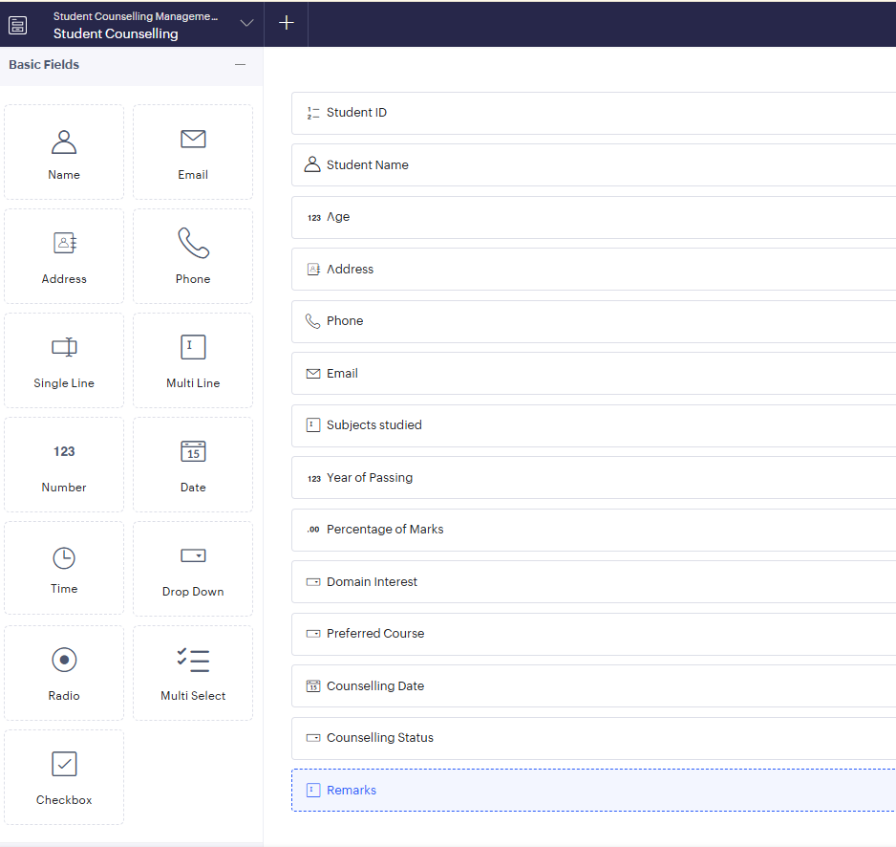
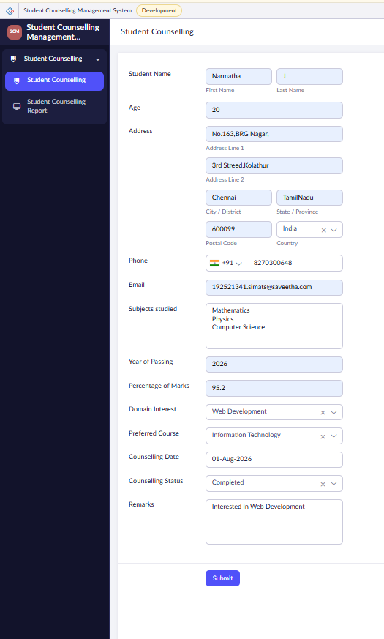

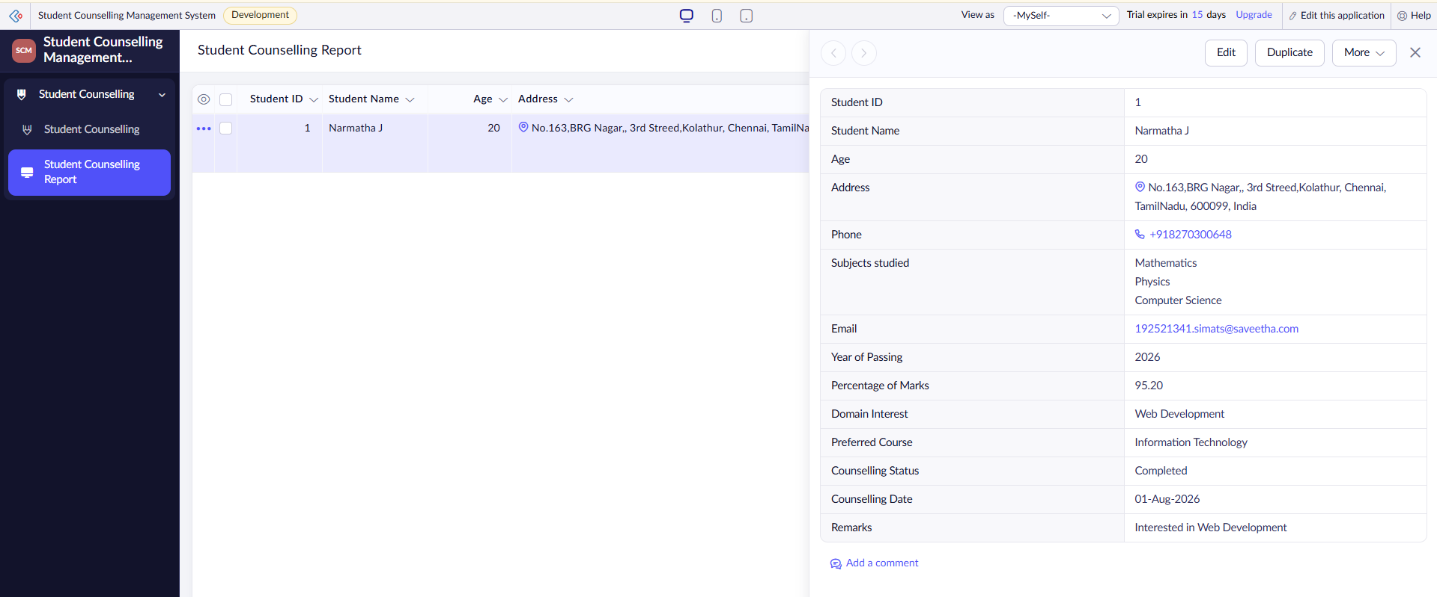
Result:
The Student Counselling System was successfully developed using Zoho Creator. The application allows counsellors to manage student personal details, academic information, domain interests, and counselling records in the cloud. This demonstrates the Software as a Service (SaaS) model.

EXP. 9: Create a simple cloud software application for Hospital information system for SIMATS Hospital using any Cloud Service Provider to demonstrate SaaS with fields of patient name, age, address, phone, email, Attender name, attender phone, doctor name, diseases, etc.

Aim:
To develop a simple Hospital Information System for SIMATS Hospital using Zoho Creator and demonstrate the Software as a Service (SaaS) model.
Software / Tools Required:
- Zoho Creator
- Web Browser
- Internet Connection
- Laptop/Desktop
Theory:
Software as a Service (SaaS) is a cloud computing model where applications are hosted on the cloud and accessed through the internet.
In this project, a Hospital Information System is developed using Zoho Creator. The application stores patient details, attender information, doctor details, disease information, and treatment status. The records are securely stored in the cloud and can be accessed and managed easily by hospital staff.

Algorithm:
- Start.
- Open the Hospital Information System.
- Enter patient details.
- Enter attender information.
- Select the doctor and department.
- Enter disease details.
- Select the admission date and treatment status.
- Submit the form.
- Store the patient information in the cloud database.
- View and manage patient records.
- Stop.
Form Fields
Field Name | Field Type
Patient ID | Auto Number
Patient Name | Name
Age | Number
Gender | Drop-down
Address | Address
Phone | Phone
Email | Email
Attender Name | Name
Attender Phone | Phone
Doctor Name | Drop-down
Department | Drop-down
Disease | Multi Line
Date of Admission | Date
Blood Group | Drop-down
Treatment Status | Drop-down

Procedure:
- Log in to Zoho Creator.
- Create a new application named SIMATS Hospital Information System.
- Create a form named Patient Information.
- Add all the required fields.
- Configure the drop-down lists.
- Save the form.
- Enter sample patient details.
- Click Submit.
- Verify that the patient information is stored successfully in the cloud database.
- View the records using the generated report.
Output:
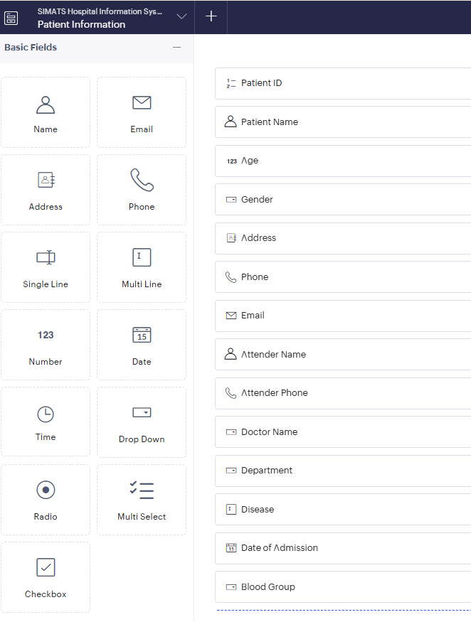

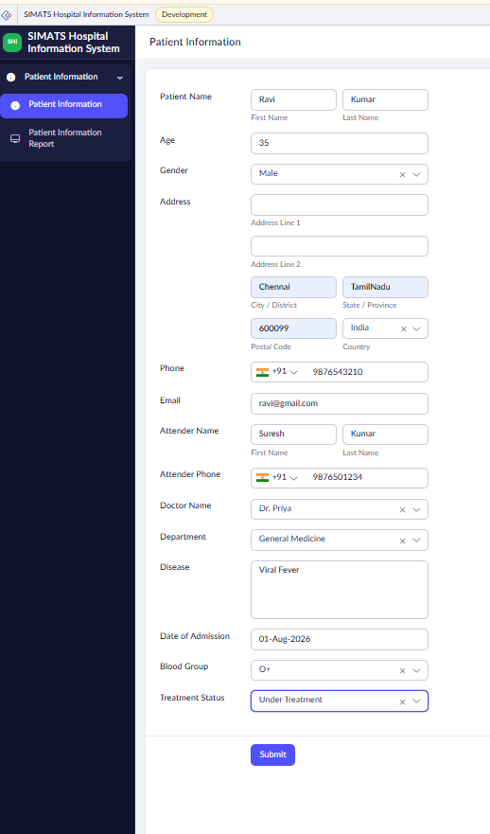

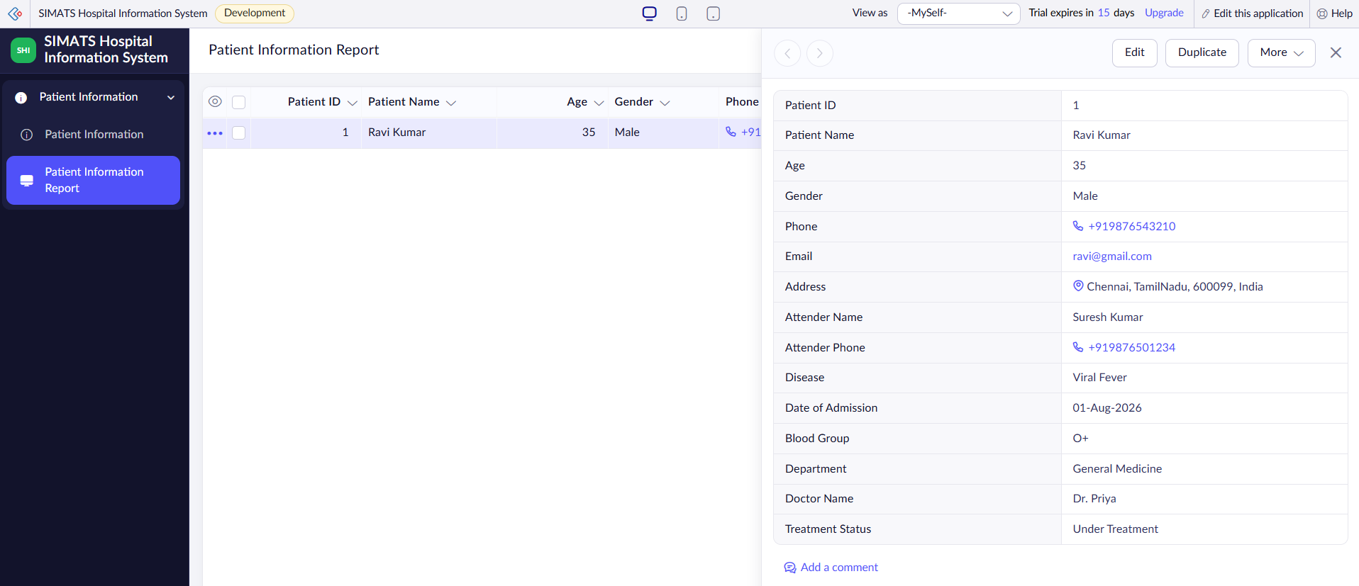

Result:
The Hospital Information System was successfully developed using Zoho Creator. The application allows users to manage patient, attender, doctor, and treatment details securely in the cloud. This demonstrates the implementation of the Software as a Service (SaaS) model using Zoho Creator.

EXP. 10: Create a simple cloud software application to run a c program to display the student information using any Cloud Service Provider to demonstrate SaaS with the template of student name, reg no, address, phone, age, courses, grades and attendance report, progress report, Semester mark sheet forms

Aim:
To develop a simple Student Information System using Zoho Creator and demonstrate the Software as a Service (SaaS) model by managing student information, attendance, progress, and semester marks.
Software / Tools Required:
- Zoho Creator
- C Compiler
- Web Browser
- Internet Connection
- Laptop/Desktop
Theory:
Software as a Service (SaaS) is a cloud computing model where applications are hosted on the cloud and accessed through the internet.
In this project, a Student Information System is created using Zoho Creator. It stores student details such as name, register number, address, phone, age, course, grades, attendance, progress, and semester marks. A simple C program can be used to display the student information. The student records are stored and managed in the cloud.
Algorithm:
- Start.
- Open the Student Information System.
- Enter student details.
- Enter course and grade information.
- Enter attendance details.
- Enter progress and semester marks.
- Submit the student information.
- Store the details in the cloud database.
- Run the C program.
- Display the student information.
- Stop.

Form Fields:
Field Name | Field Type
Student ID | Auto Number
Student Name | Name
Register Number | Single Line
Address | Address
Phone | Phone
Age | Number
Course | Drop-down
Grade | Drop-down
Attendance Percentage | Decimal
Progress Report | Multi Line
Semester | Drop-down
Semester Mark | Number

Procedure:
- Log in to Zoho Creator.
- Create a new application named Student Information System.
- Create the Student Information form.
- Add the required student fields.
- Create Attendance Report, Progress Report, and Semester Mark Sheet forms.
- Enter sample student details.
- Save and submit the records.
- Verify that the student information is stored in the cloud.
- Write and run the C program using a C compiler.
- Display the student information using the C program.
- View the stored records using Zoho Creator reports.
Output:
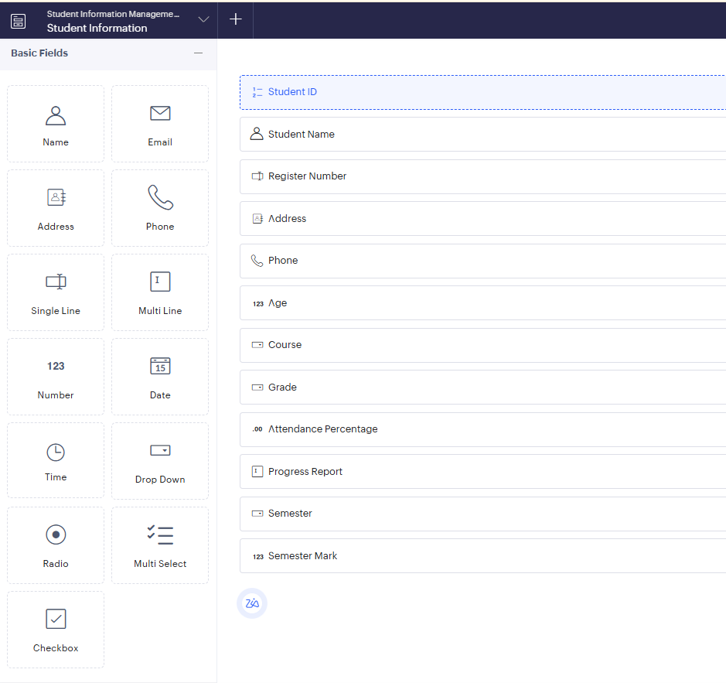

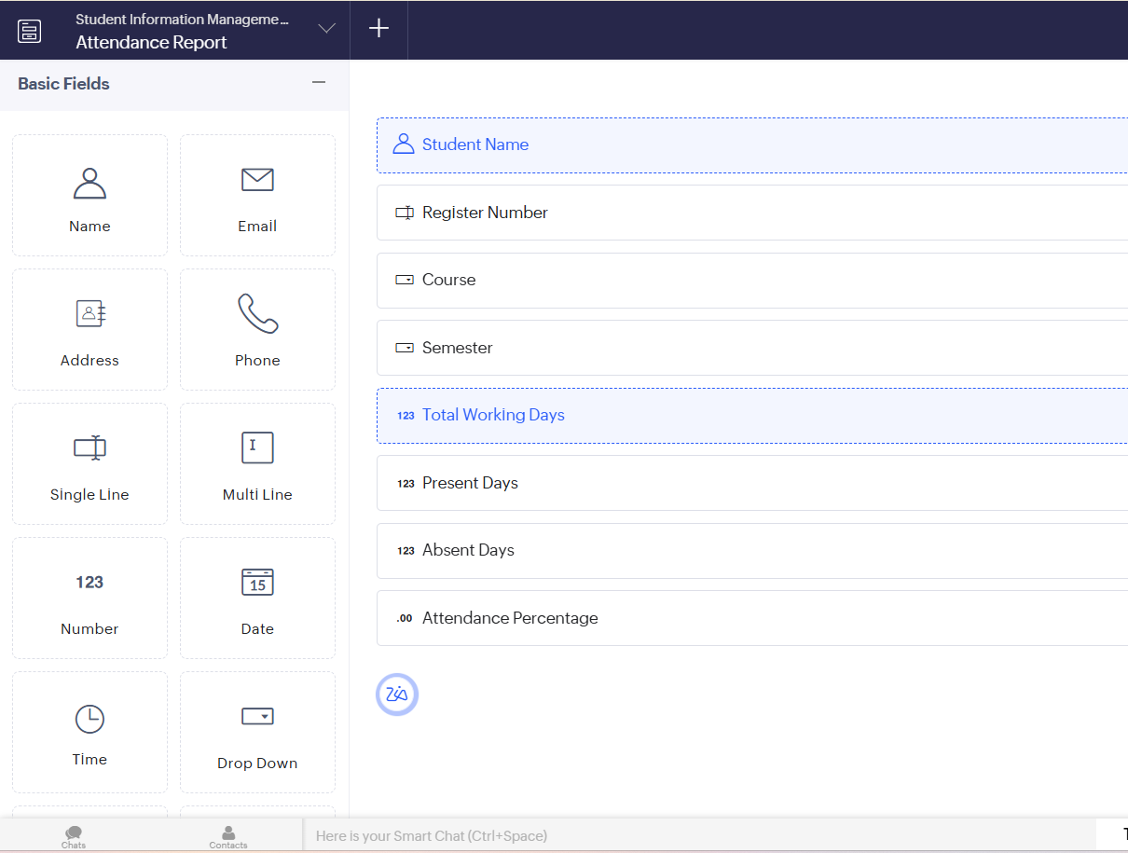
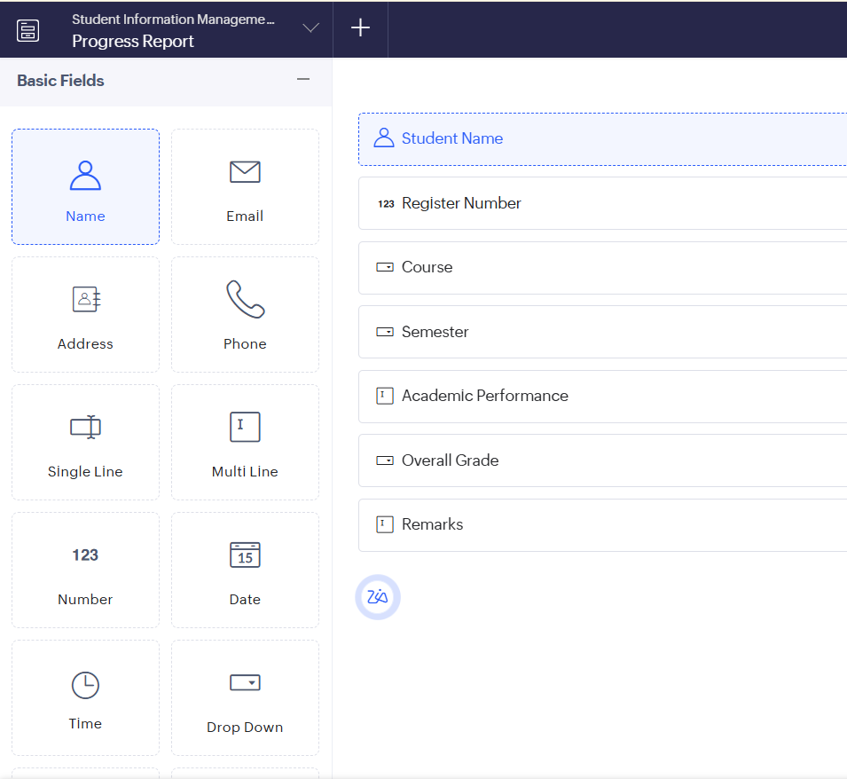

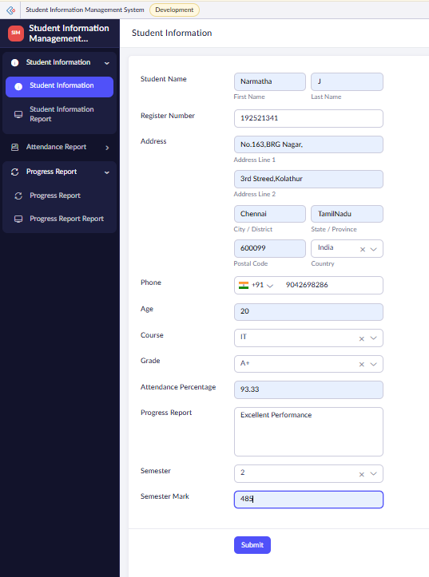

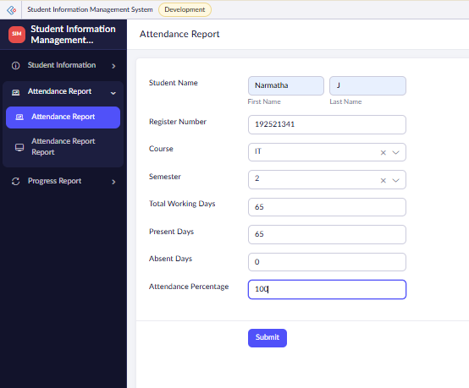

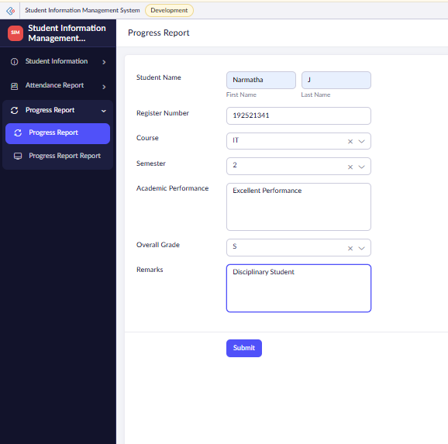

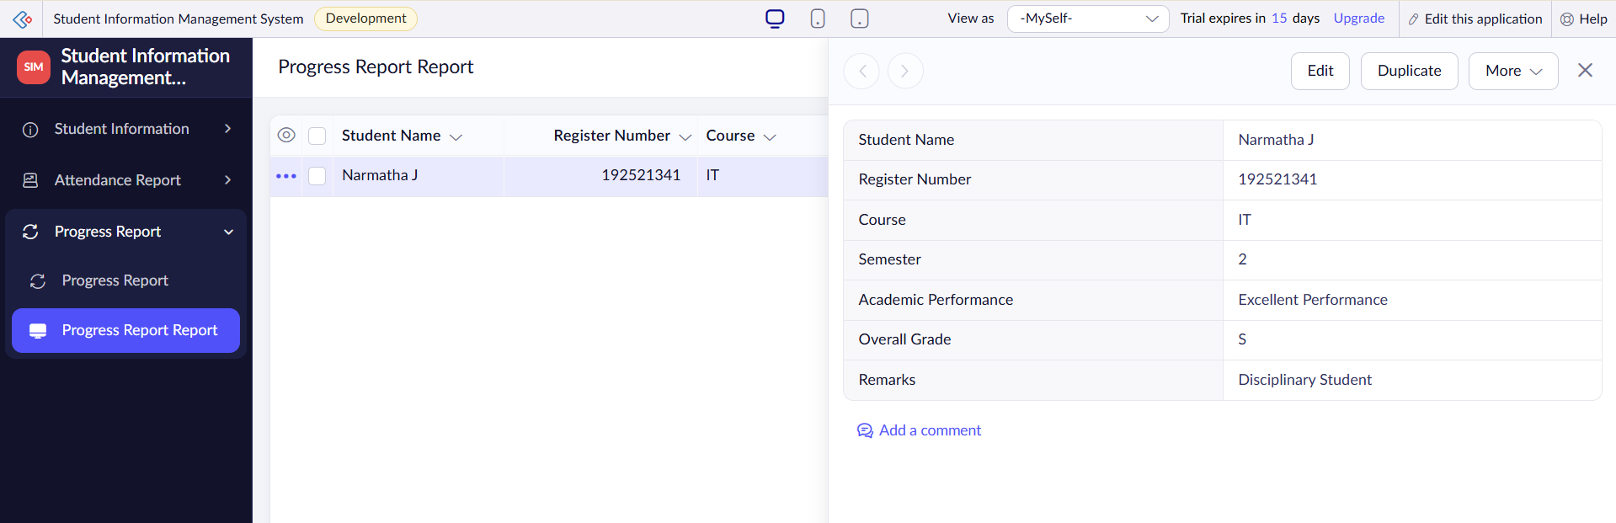
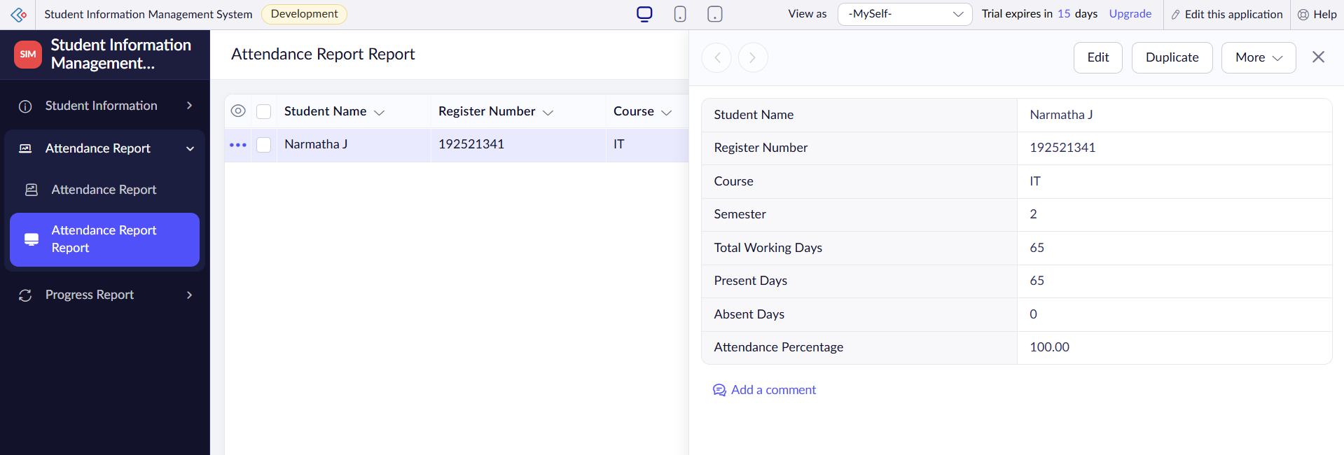
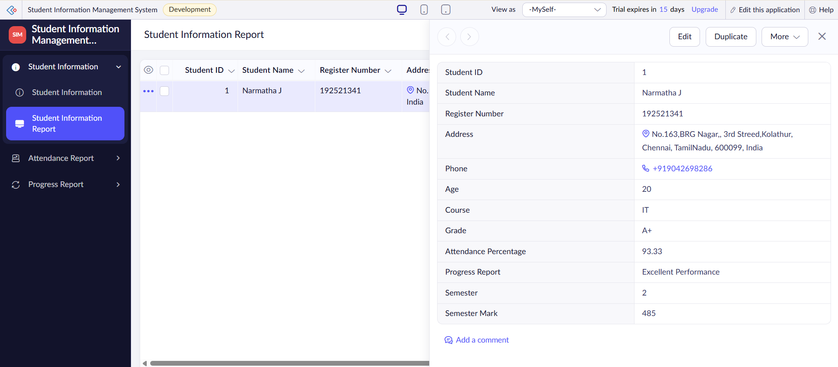
Result:
The Student Information System was successfully developed using Zoho Creator. Student details, attendance, progress, and semester marks were stored and managed in the cloud. The C program was used to display the student information, demonstrating the SaaS model.

EXP. 11: Create a simple cloud software application for online super market using any Cloud Service Provider to demonstrate SaaS with the template of customer name, address, phone, email, items, quantity etc. with the classification form.

Aim:
To develop a simple Online Supermarket System using Zoho Creator and demonstrate the Software as a Service (SaaS) model.
Software / Tools Required:
- Zoho Creator
- Web Browser
- Internet Connection
- Laptop/Desktop
Theory:
Software as a Service (SaaS) is a cloud computing model where applications are hosted on the cloud and accessed through the internet.
In this project, an Online Supermarket System is developed using Zoho Creator. The application allows customers to enter their details, select items, specify quantity, and place orders. An item classification form is used to manage products according to their categories. All information is stored in the cloud.

Algorithm:
- Start.
- Open the Online Supermarket System.
- Enter customer details.
- Select the item and category.
- Enter the quantity.
- Check the item availability.
- Calculate the total amount.
- Enter payment details.
- Submit the order.
- Store the order information in the cloud.
- Stop.
Form Fields:
Customer Order Form:
Field Name | Field Type
Order ID | Auto Number
Customer Name | Name
Address | Address
Phone | Phone
Email | Email
Item Name | Drop-down
Item Category | Drop-down
Quantity | Number
Price | Currency
Total Amount | Currency
Order Date | Date
Payment Status | Drop-down

Item Classification Form:
Field Name | Field Type
Item ID | Auto Number
Item Name | Single Line
Category | Drop-down
Brand | Single Line
Price | Currency
Available Quantity | Number
Unit | Drop-down
Item Status | Drop-down

Procedure:
- Log in to Zoho Creator.
- Create a new application named Online Supermarket System.
- Create a Customer Order form.
- Add customer and order details.
- Create an Item Classification form.
- Add item name, category, price, quantity, unit, and status fields.
- Configure the required drop-down values.
- Save the forms.
- Enter sample customer and item details.
- Submit the order.
- Verify that the records are stored successfully in the cloud database.
- View the records using reports.

Output:
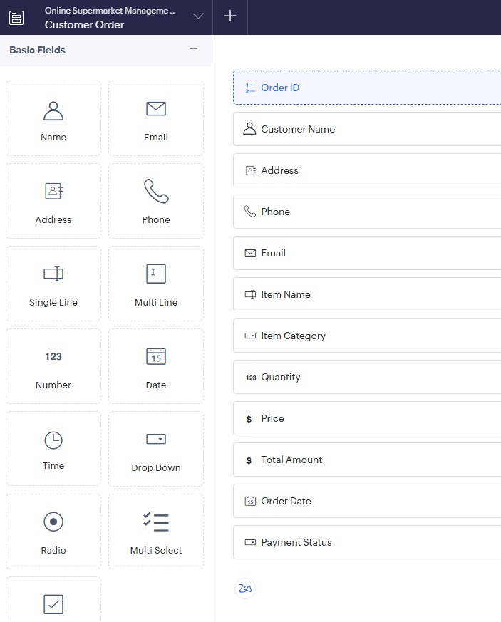

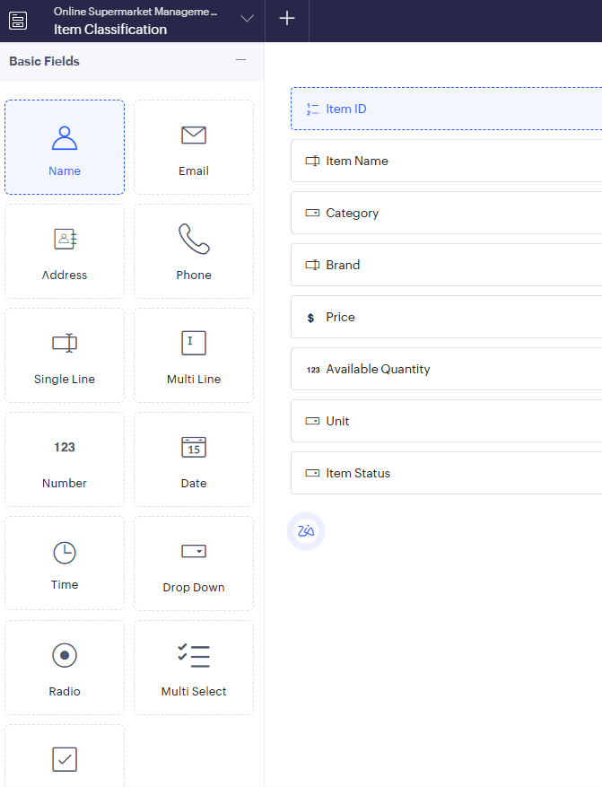

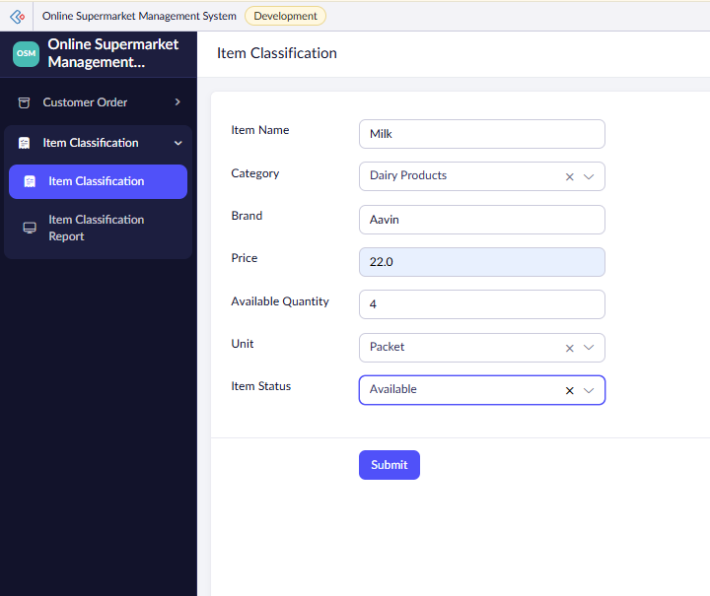
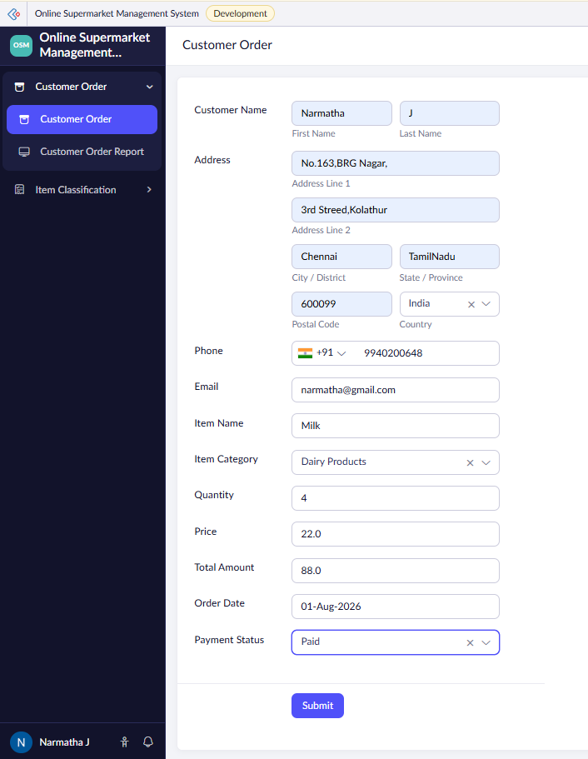
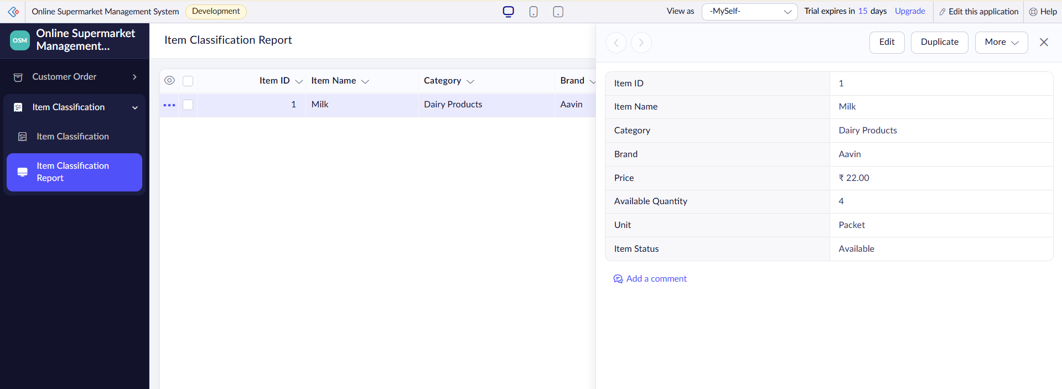
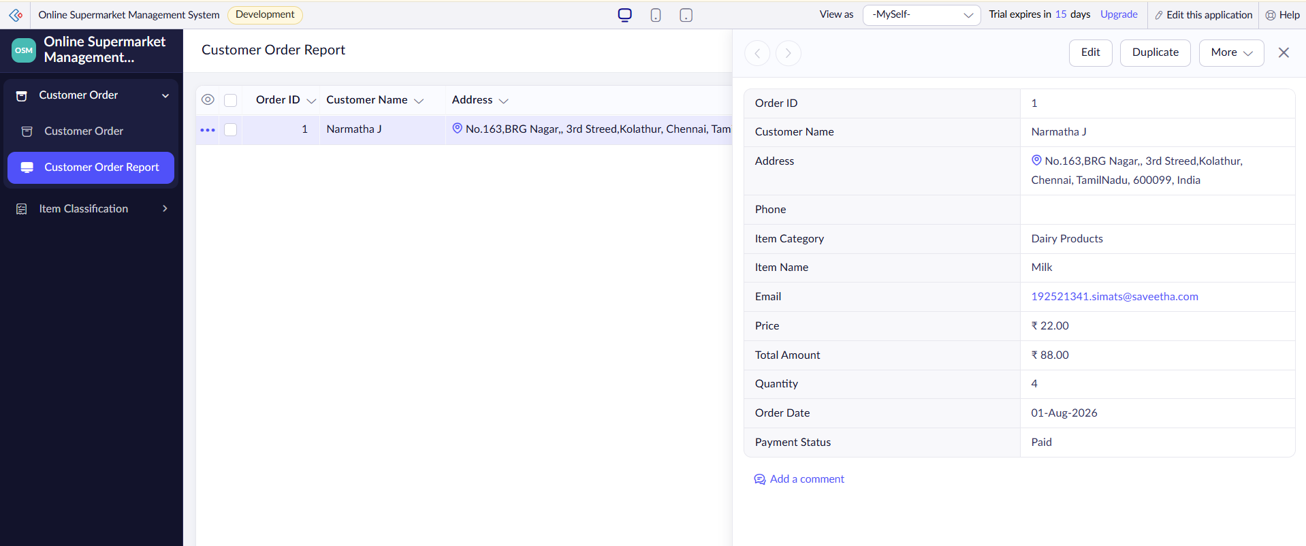

Result:
The Online Supermarket System was successfully developed using Zoho Creator. The application allows customers to manage their details, select items, specify quantities, and place orders. The item classification form helps organize supermarket products. The data is stored in the cloud, demonstrating the SaaS model.

